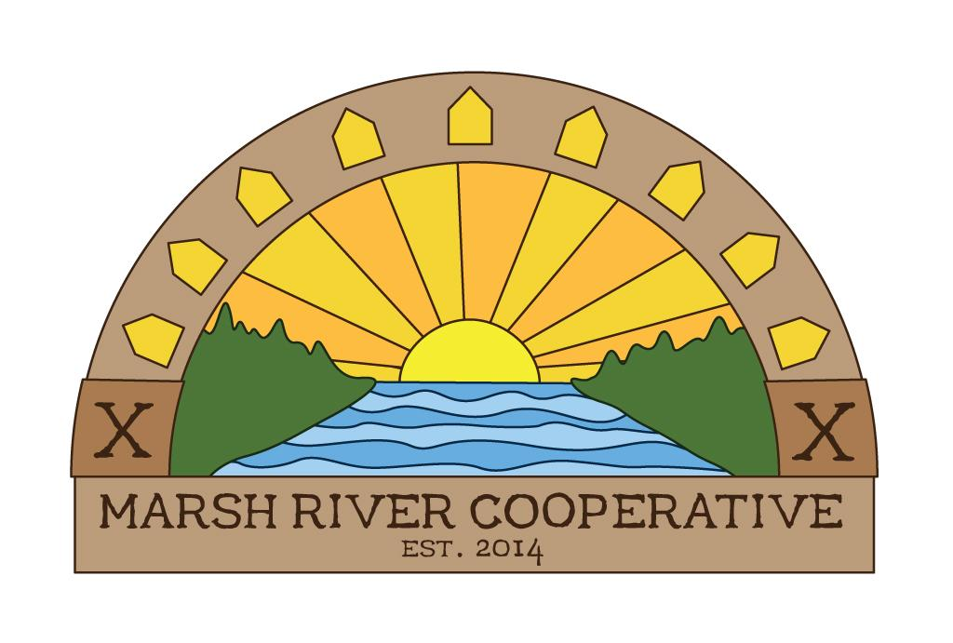
Marsh River Cooperative
Consumer Member Application
Updated 01 April 2019
Date: ______________________
Name:______________________________________________________________
Mailing Address: ________________________________________________________
Town: ______________________________ State: _________ Zip: ______________
Phone: ( ) _____________ Email: __________________________________
Preferred method of communication (check one): □ Snail mail □ Email
FEES AND PAYMENT OPTIONS
- There is a $50 one-time share purchase/equity payment and $15 annual fee for consumer memberships.
  - $15 Annual Fee is wavied for first year

Signature of Applicant: _______________________________________________________________

FOR COOP USE ONLY:

Membership payment of $_____ received by: ______________________ Date:___________

